South African Soccer Dataset – SQL
- View the first 100 rows of the dataset to understand its structure.
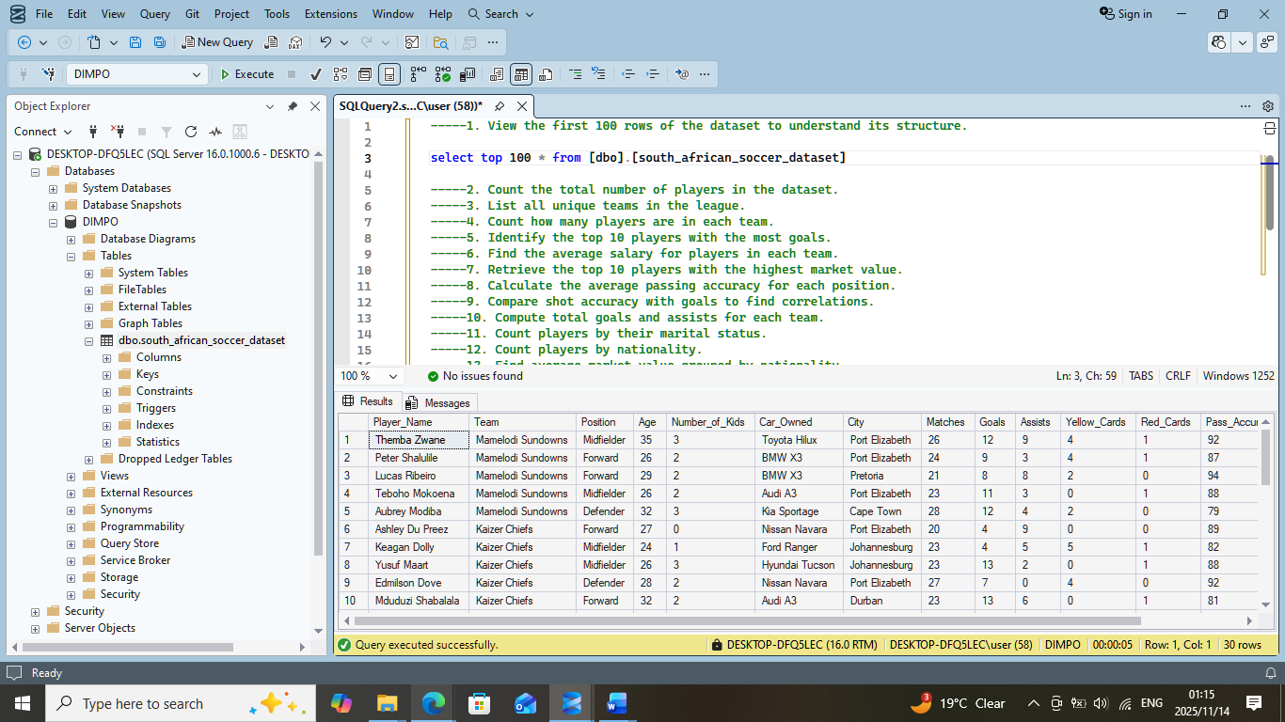
2. Count the total number of players in the dataset.
3. List all unique teams in the league.
4. Count how many players are in each team.
5. Identify the top 10 players with the most goals.
6. Find the average salary for players in each team.
7. Retrieve the top 10 players with the highest market value.
8. Calculate the average passing accuracy for each position.
9. Compare shot accuracy with goals to find correlations.
10. Compute total goals and assists for each team.
11. Count players by their marital status.
12. Count players by nationality.
13. Find average market value grouped by nationality.
14. Determine how many player contracts end in each year.
15. Identify players whose contracts end next year.
16. Summarize the number of players by injury status.
17. Calculate goals per match ratio for each player.
18. Count how many players are managed by each agent.
19. Calculate average height and weight by player position.
20. Identify players with the highest combined goals and assists.

-----1. View the first 100 rows of the dataset to understand its structure.

select top 100 * from [dbo].[south_african_soccer_dataset]

-----2. Count the total number of players in the dataset.

select * from [dbo].[south_african_soccer_dataset]

select count (*) as Total_players
from [dbo].[south_african_soccer_dataset]

-----3. List all unique teams in the league.

select distinct team
from [dbo].[south_african_soccer_dataset]

-----4. Count how many players are in each team.
-----5. Identify the top 10 players with the most goals.
SELECT
player_name,
goals
from [dbo].[south_african_soccer_dataset]
ORDER BY
goals DESC
LIMIT 10
-----6. Find the average salary for players in each team.
-----7. Retrieve the top 10 players with the highest market value.
-----8. Calculate the average passing accuracy for each position.
-----9. Compare shot accuracy with goals to find correlations.
-----10. Compute total goals and assists for each team.
-----11. Count players by their marital status.
-----12. Count players by nationality.
----13. Find average market value grouped by nationality.
----14. Determine how many player contracts end in each year.
-----15. Identify players whose contracts end next year.
----16. Summarize the number of players by injury status.
-----17. Calculate goals per match ratio for each player.
-----18. Count how many players are managed by each agent.
----19. Calculate average height and weight by player position.
----20. Identify players with the highest combined goals and assists.
----1.View the first 100 rows of the dataset to understand its structure

select top 100 * from [dbo].[ketro_sa_soccer_dataset_advanced]

-----2. Count the total number of players in the dataset.

select * from [dbo].[ketro_sa_soccer_dataset_advanced]

select count (*) as Total_players
from [dbo].[ketro_sa_soccer_dataset_advanced]

-----3. List all unique teams in the league.

select distinct team
from [dbo].[ketro_sa_soccer_dataset_advanced]

-----4. Count how many players are in each team.
select team, count(*) as player_count
from [dbo].[ketro_sa_soccer_dataset_advanced]
group by team;

-----5. Identify the top 10 players with the most goals.
select top 10 player_name, goals
from [dbo].[ketro_sa_soccer_dataset_advanced]
order by goals DESC;

-----6. Find the average salary for players in each team.

-----7. Retrieve the top 10 players with the highest market value.

select top 10 player_name, market_value_zar
from [dbo].[ketro_sa_soccer_dataset_advanced]
order by market_value_zar desc;

-----8. Calculate the average passing accuracy for each position.

select position, count(*) as avg_passing_accuracy
from [dbo].[ketro_sa_soccer_dataset_advanced]
group by position;

